- Creating the Grasshopper appliance image

  - Introduction

This chapter describes how the Grasshopper appliance image was set up.

  - Downloading & installing the operating system

DietPi was chosen as the base operating system for the Grasshopper appliance, since this is a lean and mean distribution where obsolete packages were stripped and removed from the official Raspbian image to give a bare minimal Raspbian server ( DietPi-Core). This allows for optimal performance of Grasshopper.

    - Download DietPi

- Download DietPi from http://fuzon.co.uk/phpbb/viewtopic.php?f=8&t=9

    - Write DietPi to SD card

- Unzip/extract the DietPi.7z image (ideally your desktop).
- insert an SD Card into a card reader on your PC
- Download http://sourceforge.net/projects/win32diskimager/
- Install and Run win32diskimager
- Click open (blue folder) and select the DietPi_vxx.img file you extracted to your desktop
- Select the Drive Path to your SD card (eg: d:).
- Click Write. Verify this is your SD card, then confirm

    - DietPi first boot

- Plug the SD card into your Raspberry Pi and turn it on.
- Wait for DietPi to complete the filesystem expansion (this will automatically reboot your Pi 2 times). Once completed, the login screen will appear.

    - Login to DietPi using Putty & finalise setup of DietPi-Core

- Open PuTTY and start an SSH session with your DietPi
- username = root
- password = raspberry
- Press [OK] (Enter) on the blue "license" screen
- Automatic update is run ( at the time of writing this manual, v5.6 was updated to v5.7)
- Press [OK] (Enter) to reboot DietPi
- Restart the PuTTY session after reboot finishes
- Press [OK] (Enter) on the blue "license" screen
- Press [OK] (Enter) on the blue "Welcome" screen
- Press [NO] (Enter) on the blue "Dedicated USB Harddrive" screen
- Press [OK] (Enter) on the blue "Questions Completed" screen
- Select "Go Start Install" (using the arrows) and press enter
- Select "DietPi-Core" on the blue "No Software Selected!" screen and press enter

The system will finalise installation and reboot.

  - Installing Lesp



LESP : Linux, Nginx, SQLite and PHP

First, start an SSH session with your DietPi using PuTTY
- username = root
- password = raspberry

    - Update the system

apt-get update && apt-get upgrade

    - Install Nginx

apt-get install nginx

    - Install SQLite

apt-get install sqlite3

    - Install PHP and extensions

apt-get install php5-fpm php5-sqlite php-apc

    - Configure NGinx default site in the file /etc/nginx/sites-available/default

nano /etc/nginx/sites-available/default

In this file, uncomment or change following parameters to match below. !!!!!!Don't remove anything!!!!!!!, just update if a parameter doesn't match:

server {
listen 80;

root /var/www;
index index.php index.html index.htm;

location / {
try_files $uri $uri / index.html;
}

location ~ \.php$ {
fastcgi_split_path_info ^(.+\.php)(/.+)$;
fastcgi_pass unix:/var/run/PHP5-fpm.sock;
fastcgi_index index.php;
include fastcgi_params;
}
}

    - Restart Nginx

service nginx restart

  - Installing Python

apt-get install python python-mysqldb

  - Put the Grasshopper files on DietPi

    - Install ProFTP

Start an SSH session with your DietPi using PuTTY

dietpi-software

- Select " 1 Select DietPi Optimized Software" and press [enter]
- Select "ProFTP" and press [OK]
- Select "Go Start Install" and press [enter]
- Select [Start Install] and press [enter]
- Select "From inetd" and press [OK]

The system will reboot once ProFTP is installed.

nano /etc/proftpd/proftpd.conf

update following:

DefaultRoot /

Save and close proftpd.conf

/etc/init.d/proftpd restart

    - Copy Grasshopper files

Create the www directory.

mkdir /var/www

- On your client PC, open FileZilla & make an FTP connection to DietPi
- locate the Grasshopper files on your harddrive and copy them to DietPi in the /var/www folder

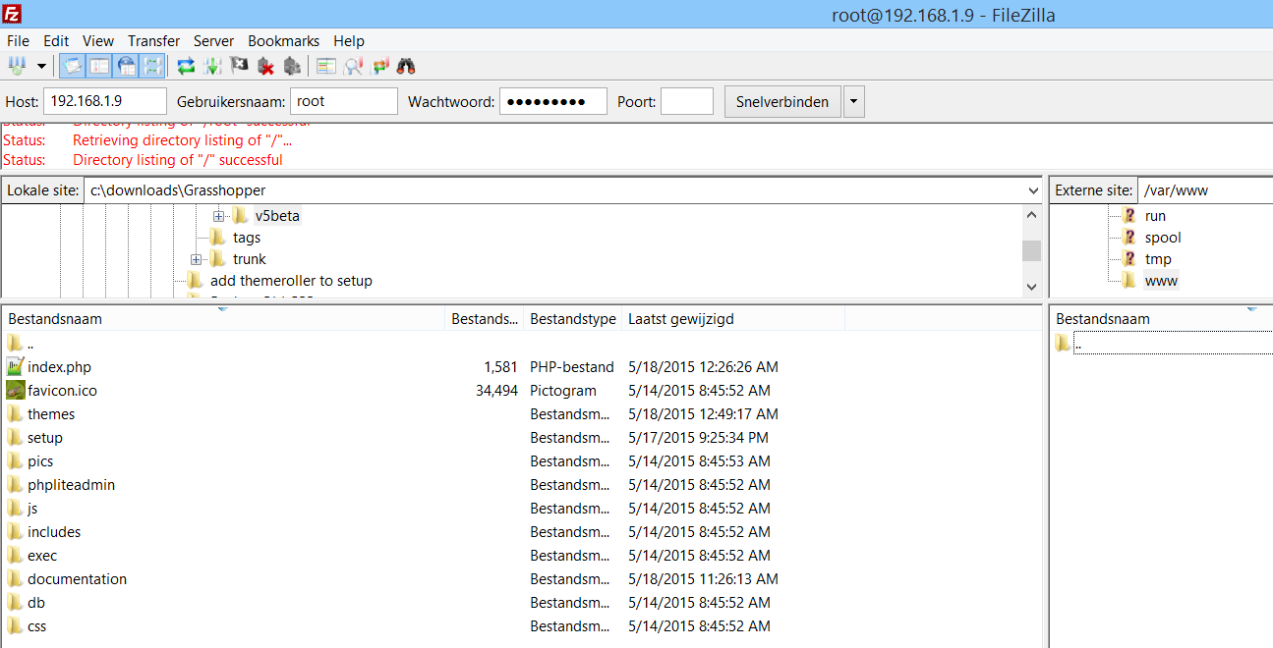

Start an SSH session with your DietPi using PuTTY

cd /var
chmod 777 www -R

    - Install and configure sudo
* this is required so the www-data user (webserver user) can execute the shell_exec commands in ./setup/tools/expandfilesystem.php. This php file is called from the "Expand Filesystem" button on the "System Tools" tab in /setup.

install sudo:
apt-get install sudo

configure sudo:

visudo

underneath %sudo ALL=(ALL:ALL) ALL add:

www-data ALL= NOPASSWD: /var/www/setup/tools/raspi-expand-rootfs.sh
Cmnd_Alias SHUTDOWN = /sbin/shutdown
www-data ALL= SHUTDOWN
www-data ALL= NOPASSWD: SHUTDOWN

Save and close the file.

In the terminal, enter:

chown www-data:root /var/www/setup/tools/raspi-expand-rootfs.sh
chmod 500 /var/www/setup/tools/raspi-expand-rootfs.sh

    - Install the Grasshopper monitor

- create some new folders on the pi:

/home
/home/pi
/home/pi/domotica
/home/pi/domotica/log
- Put the launcher in place
- Give sufficient access rights

mkdir /home /home/pi /home/pi/domotica /home/pi/domotica/log
cp /var/www/exec/monitor/launcher.sh /home/pi/domotica/launcher.sh
cd /home/pi/
chmod 777 domotica -R

- Run monitor at startup

crontab -e

add the following line to crontab:

@reboot sh /home/pi/domotica/launcher.sh >/home/pi/domotica/log/cronlog 2>&1

Save and exit crontab

- Reboot Grasshopper

shutdown -r now

  - Clean Grasshopper configuration

    - Clear room configuration

nano /var/www/includes/myhome.conf

- clear everything in the file
- save & close

    - Clear Gateway IP configuration

nano /var/www/exec/ownGateway.conf

- only clear the values in the file, so the file looks like:

[GATEWAY]
HOST=
PORT=
PASSWORD=

- save & close

    - Delete SQLite database

rm /var/www/db/grasshopper.sqlite

    - Delete documentation folder

rm /var/www/documentation/ -R

    - Shutdown the Pi

shutdown now

  - Make the Grasshopper image file

This section continues in Linux (eg. Mint / Ubuntu / ...) on the client PC.

The SD card has been taken out of the Pi and put in the card reader of the client PC.

    - Resize the partition

- Open GParted and select the ext4 partition on the SD-card
- select the SD card from the drop-down list (at time of writing, /dev/mmcblk0, MAY DIFFER)
- select the ext4 partition on the SD-card (at time of writing, /dev/mmcblk0p2, MAY DIFFER)
- Unmount that partition (right-click menu)
- Look at "Used" size (during time of writing it was 900MB)
- Resize the partition (I chose 950MB)
- From the menu, choose edit - apply all operations

    - Make image file from the SD-card

- Open a terminal

Make an image file from the current SD-card by entering:

sudo dd if=/dev/mmcblk0 of=/home/YOUR_USERNAME/Desktop/grasshopper.img bs=1M count=1050

"if=/dev/mmcblk0" (mmcblk0 is the name of your SD card, it could be different on your system.)
"of=/home/YOUR_USERNAME/Desktop/grasshopper.img" (This is where you want to send your backup. Change "YOUR_USERNAME" to your real linux home folder name of course, but you can send it anywhere you want.)
"bs=1M" (This specifies block size. Here we've said copy over blocks of one megabyte (1024x1024 bytes) at a time. Read the man page for dd if you want to change this value.)
"count=1050" (This is how many blocks to copy over. In this example we've said copy over only 1050 blocks and then stop. Because we set the block size as 1 megabyte, we will get an image that is 1050 times 1 megabyte). This size was chosen to give some headroom for "/boot" partition (56MB) and "/" partition (950MB).

